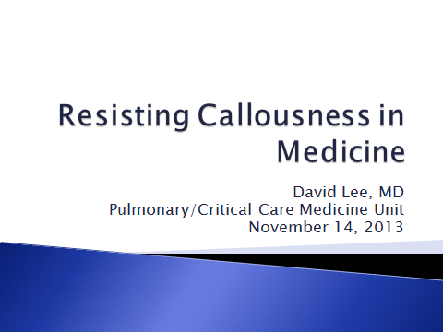

Good morning, colleagues.

I know many of you, having worked with you for most of the past 23 years. Some of you I don’t know, but might get to know in the next few years. Thank you all for coming.

I stand up today to speak about things we don’t examine every day. What I will be touching on is not about empirical material: things that can be measured or proven by hypothesis testing. Rather, I will try to remind myself and you of another realm of experience that can motivate and support us in our work as physicians. That is, the realm of connection and meaning: what provides meaning to our professional and personal lives?

I can speak to each of you only as a guide, not an authority or a teacher. Each of you has your own path to discover. As we have passed from student to resident to fellow and junior attending, as we gained confidence and prestige and competence, we have had many triumphs and more than a few failures. The impacts of those experiences have strengthened some of our identities, and damaged other aspects of our selves. Speaking for myself, I have had little opportunity until recently to reflect on what I have become as a result of what I have witnessed as a physician.

So my intent today is to remind ourselves of our privilege and burden: to be physicians to a community that still wishes to place its trust in our powers and our goodness. We (from student to emeritus) share this, but we also face the suffering of dozens of patients almost every day – how can we not become calloused, self-absorbed and self-preserving, eventually angry with the forces that seem to demand and demand with sometimes inadequate compensation to replace what it drains from us?

I do not have answers for everyone. But I will point out that we live in modern America, part of a pluralistic, diverse, global community. The challenges and solutions of the past will not be those that today’s residents will have to face. But patients will be patients, and my thesis is that the knowledge gained through the philosophers and the religions will help to sustain us. I am here today to speak up for appreciation of a spiritual dimension to life that provides meaning to us, and I speak against the idea that nothing matters except that which is rational and measurable.
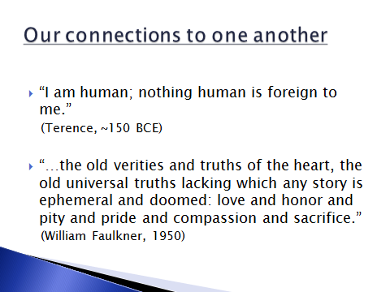
The Roman playwright Terence said around 150 BCE: “I am human; nothing human is foreign to me.”
William Faulkner in 1950 was referring to the task of poets and writers, when he said that they must write of “the old verities and truths of the heart, the old universal truths lacking which any story is ephemeral and doomed - love and honor and pity and pride and compassion and sacrifice.”

But he could also have been speaking of the best parts of us as we relate to our patients. These parts of our patients and our selves matter. We encounter not only their glands and organs, as it were, but also their hearts. And we are not only glands and a mind; we also have to care for and nurture our hearts and our dreams. It is what connects us to them.

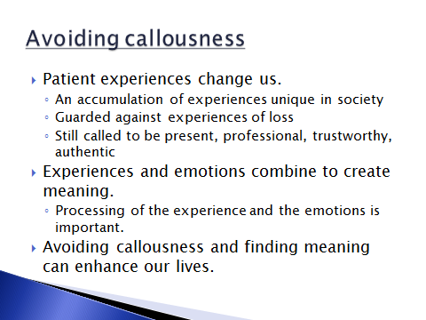

Mrs. R is an 82 y/o patient on 5400 for the past 40 months. She has COPD on a ventilator, ESRD on dialysis, obesity and a “difficult personality.” At one time I was closely involved in her care, advocating for trach then PEG, advocating for empathy for her, for her family and for her difficult history, and wondering how long this could go on. It has gone on for more than a year since I last saw her. I have to admit that I have some guilt that I have not seen her in all that time. But she has achieved some seeming balance of dependency on the staff on 5400 without exhausting them with her demands and bouts of angry rejection. She claimed that her Catholic beliefs prevent her from foregoing life support, as that would be like suicide; she forbids any further conversation on that issue.

Mr. P was a 77 y/o man who died of lung cancer this past summer. His wife was a double lung transplant patient who had 8 years of relatively good life after 8 months of ventilator dependency after her transplant for scleroderma lung disease. Mr. P adored his wife, and his family said that when she died of progressive lung rejection, he lost his reason for living. He was not withdrawn, but he never lived a day without thinking of Joanne. He developed lung cancer in 2013, and wanted only symptom management for his dyspnea. He said that he was ready to die, and would not go out and “max out my credit card” like some of his acquaintances said they would do in his position. He was raised Catholic, but was not particularly religious, and did not ask for a priest to see him while in the hospital.

These are two of my more memorable patients, and I am sure you also have memories of patients you remember, and others you may try not to remember. This accumulation of patients constitutes the experiences of all of us, and no one else in society. We go from the code to the next admitted patient, from the patient we cared about to the one whom no wants to care about. And sometimes we are called unfortunately to mourn our own losses of parents, friends and relatives: for me it takes a strenuous effort now to really feel loss, because I have philosophized and intellectualized so many other losses. We do become set apart: called to be present but not hurt, “professional” despite our stressors, trustworthy even when we aren’t confident, real after so much effort insulating ourselves from emotions.

I can only trust that I have not exaggerated your experiences. I hope that what I have touched or reminded you of is the emotional side of our experiences as internists. It is what binds us: we know this not because we have studied it, read about it, or even talked about it much. But those moments and what we eventually do with them, count toward who we become.

Don’t let anyone deny you the value of that experience. Don’t forget it – burying it in the tasks and demands of notes and rounds. It lives within you, and how you process it affects who you are and who you become. I do not think it is an exaggeration to say that it also affects who we are as parents and friends – in all of the roles and guises we own.

And that is what I hope to talk about today – making meaning in our lives, and how important it is not to let taking care of patients make us callous, hardhearted as individuals, a community and a society. Is a life only of efficiency and striving and longevity what we dream of and work for? When we develop the illnesses our patients have, how much like Mrs. R or Mr. P will we be?

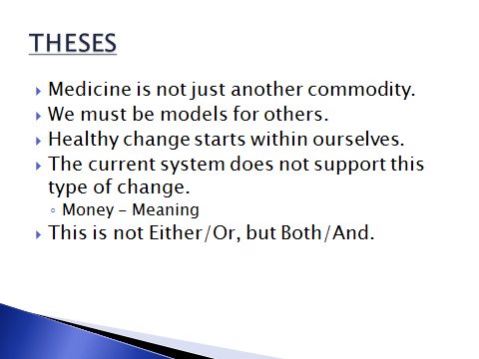

My theses will be:
- There is more to medicine than tests and procedures, billing and documentation. Medicine is not just another commodity. There are human relationships at stake. Patients hope for trustworthiness, steadiness and empathy; not only technical expertise, but care, and sometimes even compassion and the simple gift of presence.
- As physicians who have come this far, we are privileged and we are talented. Therefore also, we are models for others. I would hope that we would create our lives as artfully as possible, to make ourselves worthy models for others.
- Healthy change starts with our selves. We are not machines and we are not enslaved. But to make good choices we have to start with self-examination and self-knowledge. There is a Dark Side within us as well as our imagined virtues.
- The current system and culture do not easily support this type of growth. The conflict between making money and making meaning is age-old, and will not end with us. But neither are we excused from working for a better system and a better world.
- This is not an alternative (an Either/Or choice) but an addition to the system and culture we have inherited. I am advocating evolution, not revolution.

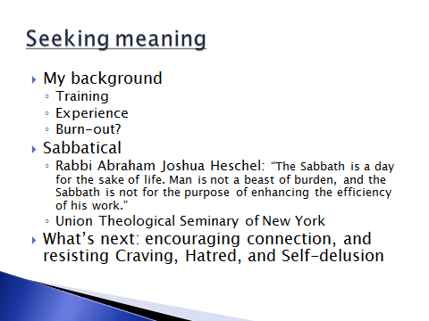

So what, more specifically, will I talk about today?

My Background and my coming close to burning out.
- I am the product of my times – I will describe some of the influences that brought me to this position of privilege. And I will describe the questions I thought I would raise in pursuing a sabbatical at a divinity school.
- But I was burning out: I was working too hard, and it seemed that the system of care I was in was not supportive of patient-oriented medical care.

My sabbatical
- Why take a sabbatical?
  - A sabbatical is a break, a ceasing from work: apparently (according to Wikipedia) 20% of companies in UK provide for this.
  - But why take a break anyway? We all understand work – especially the 24/7 need in a hospital to provide services to the many who need them. Aristotle argued that relaxation was virtuous not because it was an end, but because it allowed one to exert oneself better (Nichomachean X, 6). But the Hebrew Sabbath, argues Rabbi Heschel, was different, and served a deeply religious purpose: “The Sabbath is a day for the sake of life. Man is not a beast of burden, and the Sabbath is not for the purpose of enhancing the efficiency of his work.” My sabbatical was not to rest me to return to the same work, but to find new ways of looking at things.
- Why Union Theological Seminar? In other words, why a divinity school?
  - I found that Religion seemed neither necessary nor sufficient to alleviate suffering at the end of life. Neither are medications. What dimension and what aspects of life also allow for the alleviation of suffering?
  - What is meant by “suffering” anyway?

And I want to talk today about how what I learned could be used in our community. How to make connections and resist the callousness that comes from craving, hatred and self-delusion.

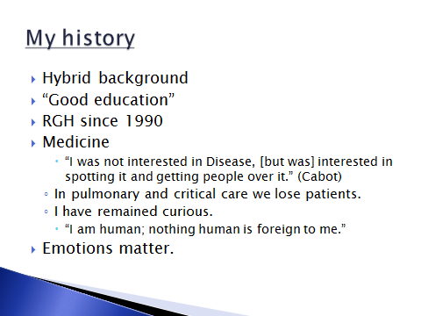

My character is hybrid: my parents came to the US after WWII, sent by the then Chinese government to bring skills back to China. They married in 1952, I was born in 1953, and I was raised in household that was Confucian and Christian Protestant in its values, and which always looked at Chinese culture as providing values at least as valuable as American values. But as first generation immigrants they wanted their children to fit in.

I was expected to excel in academics. I was sent to boarding school for that reason, and was able to go to Ivy League schools for my education. It was a liberal education, and my religious involvement was oriented in a liberal Protestantism – social justice, civil rights and resistance to the Vietnam War were the causes, not a personal-salvation type of Christianity.

I joined RGH in 1990. I love my work as a physician, but also worry that it has come to dominate my personality: the control and mastery inherent in this type of unequal relationship may also be a defense against close investment in other types of relationships.

I have always enjoyed the technical aspects of internal medicine, and I have always valued the feeling of being of service to others. The psychosocial aspects of medicine are much less manageable it seems than the biomedical, but they are clearly important in the lives of patients. I have been curious to understand the sources of emotional strength in patients and the means of providing emotional support to them. As a famous doctor of the 1920s said: "I was not interested in Disease [but was] interested in spotting it and getting people over it."

In critical care and pulmonary medicine we lose patients. It is the final common pathway, after all the temporary saves and the heroics. We know that patients wish not to feel abandoned. It is a difficult consequence of making attachments that we also need to be careful not to let patients down when we find ourselves empty-handed. Empty-handedness is what we become eventually, and it makes many doctors very, very uncomfortable. The prospect of that ultimate limitation is a good reason not to reach out emotionally in fact. And it is that fact of life – that we all die, and unfortunately, as physicians we have to be there – that fact of life may lead us to be self-protective and even callous.

I guess I have also remained curious about things. I have had the good fortune to have some very good teachers who have pointed out new ways of seeing and doing, and also who supported me as I actually did try on new ideas and behaviors. I felt I could use their appreciation and curiosity about the world of the mind – the combination of emotion and experience that creates reality as patients saw it. “I am human; nothing human is foreign to me.” This allows us to understand and empathize, and also to realize that circumstances affect outcomes.

It is possible in fact to manage many of our interactions at a technical level. But I believe that using that approach alone is not sustainable. Even when we hope or choose not to notice or address the emotional issues patients bring, those emotional forces exist. We may call that “baggage,” but it is what they imagine physicians should help them with also. They frustrate physician-patient interactions because “something else” can always come up when the agendas of patients and physicians do not coincide. For the residents I will make a plug here for becoming aware of “patient-centered interviewing,” the subject of an educational half-day this spring: a little bit of attention to listening to patients’ concerns before imposing our agendas can save time, not consume it.

But medicine based only on knowledge and technical skills is not sustainable also, I believe, because it compartmentalizes our lives. We do not perfectly isolate the emotional effects of our work from the non-medical parts of our lives. We live our expectations of ourselves, and thank goodness there are people like you who are willing to sacrifice and work and extend yourselves to be of service. But let’s not ignore that anger, shame, sadness, and fear come with the territory, all the emotions come. And if we compartmentalize them, it colors other aspects of our lives. At some level, it may prevent us from experiencing the love, happiness, curiosity and creativity that we are also entitled to. “Letting it go” isn’t as easy after a while, if we have been “keeping it in” for so long.

I bring these issues up because even a hard-boiled “realist” must sometimes admit that emotions matter, and the randomness and realities of life force us to deal with them.
We are in a crazy place: the hospital is where patients come to when they are vulnerable and suffering. In many cases, we know that things will not go well soon or eventually. We know that, and it affects us. We bear it, and repress it, and distract ourselves and try to forget about it. We try to go on in our “normal lives” as we train ourselves to develop our professional distance. I believe that that professional distance can include some ability to express empathy and compassion.

But what does any of this have to do with taking a sabbatical, and at a divinity school no less!? What led me to break from the routines of RGH and decide to expose myself to another discipline?
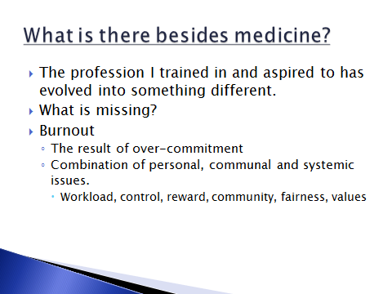

The profession of medicine I trained in and aspired to practice has evolved into something different. I do not wish to belabor the points that led me to the point of burnout.

I have been aware for years that burnout is the result of over-commitment to whatever we are doing. The mechanisms to prevent burnout are supposed to be personal, communal, and systemic. That is, we have to take care of ourselves, and we have to support each other, of course; but we also have to create or develop a system that is sensitive to the needs of its members. I believe I have done a good share of trying to support our nurses and residents, of trying to advocate for our patients in this culture of the hospital that must be so strange to them. I am sure I could do more. I buy into the idea of quality improvement as a matter of creating systems of care that are not silos; that interdisciplinary collaboration and communication are critical to safety; that a culture of safety is necessary if my family must be cared for in a hospital as large and as complex as this one.

[On top of that, I have witnessed just this year my 97 year old father’s encounter with a pretty good hospital and healthcare system in Poughkeepsie – and I see that it takes very little insensitivity to make a purportedly good system fail its vulnerable clients. As physicians we know where the problems lie. We also know how to get around the system usually, to make it work enough to our advantage. We go to the colleagues we trust the most, use the samples to save on costs, find the personnel who have the willingness to do a little bit extra. But it is not exactly the system our patients are navigating.]

My point is that it takes a lot to make the system work as if every patient every day were valued as one of our own family members. I found it meaningful to be that kind of physician to my patients. The sense of purpose and support I talked about earlier helped keep me going. The many compromises here and there were balanced by the sense that I was doing about as good a job as I could do, given the difficult circumstances. And I was spending about 60 to 80 hours a week doing this.

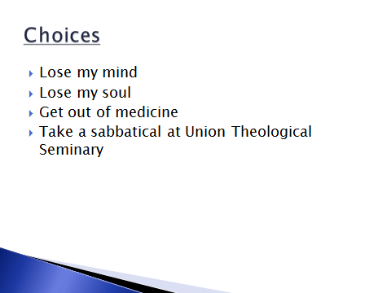

The sense of craziness increased, and the sense of meaning declined around the time the electronic record arrived. Care Connect made doing lousy work easier, and good work harder. Care Connect was not the source of the problem, but it was symptomatic of the problem, and its presence exacerbated difficulties we were already having taking care of patients. After a year or so of it, I felt I was either going to lose my mind, or lose my soul, or I would have to get out of medicine to preserve both together.

Practicing medicine had become difficult. I could not single-handedly correct the deficiencies of the electronic record; nor could I resign myself to the level of crappiness that resulted from having all this data to wade through, analyze and organize, but not enough time to do that. I was afraid to leave medicine, as it would seem that I would be leaving it to those who don’t care about it as much.

For the time being I am using the scribe system to save myself time: it allows me more and better face to face time with patients, and it allows me to document in prose and with meaning. I am in fact paying the system to make up for the increased demands it has made on me. I am not happy about this, and it will cost me. But I am closer to retaining my sanity and my integrity.

But I was talking about why I applied to spend time at a seminary for three months.

Besides what it takes to understand, recognize and perhaps relieve suffering, I guess I wanted to have an idea why some people had more or less of it. Or maybe I was just looking to try to understand my own misery: how could medicine, something so stimulating to the intellect, and engaging for the heart, still make me so miserable? What allows some people to work so hard with pleasure and creativity at this job or another, while others invest so little in the same job and seem to barely survive the day or see the potential pleasures in it?

So I applied to Union Theological Seminary in New York, a Protestant seminary near Columbia University on the Upper West Side. It is a small place (like a residential college on an Ivy League campus), but a bastion of liberal Protestant theology – chief among them the idea that God values justice and righteousness in the world, and may favor the poor over the rich. It’s pretty inclusive (it included some atheists studying there). It was impressive to step into its library, the second largest after the Vatican’s, and realize that the efforts and talents of so many thousands of men and women had been invested for centuries in religious and spiritual exploration. We pride ourselves on our medical libraries, but it is difficult to challenge that there must be something that engages many similarly gifted thinkers in another direction.

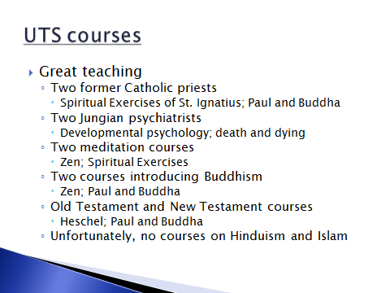
I took an eclectic course load. To say there was a lot of reading and writing would be an understatement. This was going back to take graduate classes in the humanities. The professors were a fascinating and talented group. I appreciated their intellectual rigor in their subject material. And the courses I chose reinforced one another in their subject matters.

Two of my professors were Catholics who had sought meanings outside of Vatican-directed Catholicism. Roger Haight was forbidden by Pope Benedict (the discredited one who resigned recently) to teach in Catholic institutions because of his writings that supported a Christology (the study of the nature of Jesus) that engaged insights from other world religions. Another (Paul Knitter) was a systematic theologian, a discipline that addresses and tries to reconcile controversies created by the fact of religious pluralism. His book “Without Buddha I could not be a Christian” was one we read and discussed. That book was used in a course on St. Paul and Buddha – could that first-century apostle, and writer of half the New Testament, have considered Buddhist beliefs as paths to God? After all, he could (as a former Jewish Pharisee) claim that Gentiles in the Roman world were being called to worship the God of Moses and Abraham.

Two of my professors were practicing Jungian psychiatrists (one was a practicing Buddhist in her personal life). One of their courses taught me about developmental psychology, and how religious beliefs are absorbed and developed from infancy through childhood and adulthood. The other taught about the many aspects of death and dying from a perspective of psychiatry.

Two of my courses required meditation practice. One was a daily exposure to Zen Buddhist meditation – the practice of stilling the mind in order eventually to experience a peaceful, unifying Emptiness, a state that leads to compassion for all living things. The other taught a diametrically opposite form of meditation: the Spiritual Exercises of St. Ignatius (founder of the Jesuit order) use the stories of the historical Jesus to focus feeling and imagination and intellect on how one would like to live one’s own life.

Finally, two of my courses explored new ways of looking at the Old and New Testaments. The Paul and Buddha course re-imagined Paul in the New Testament as a radical Jew – one who felt the God of Abraham was extending the legacy of Abraham to all of humanity (the Gentiles), through the life and example of Jesus, and not cutting off the Jews at all. In other words, this was a re-reading of Gospel and a re-examination of centuries of Catholic and Protestant theology – theology that would lead by its hate and exclusivity and self-righteousness inevitably to the fact of the Holocaust.

Another course, taught by Cornel West (activist, philosopher, public intellectual) studied the writings of Abraham Joshua Heschel, a mid-20th century Jewish rabbi, philosopher, mystic, and social activist. Heschel would have us start with wonder, and makes a pretty effective argument that the denial of wonder can lead to “believing we are the masters of the earth and our will the ultimate criterion of right and wrong.” He argues that it was Greek philosophy that first valued reason over emotion, leading eventually to separation of science and religion, and a denial of wonder. It would eventually lead to Western religions giving up ground to science, when it came to questions of meaning.

I unfortunately did not have time to be exposed to Hinduism or Islam. The latter in particular is difficult to teach in a seminary as opposed to a Religious Studies department in a university. I do not fully understand why, but it was certainly the case at Columbia and Union.

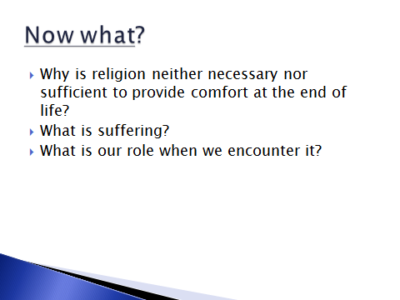
So Now What?

As I have said, I do not dare to claim that I have answers to provide, but I do have comments and observations to make. This section of this talk was difficult to manage, and it is not finished still. The purpose I want to address is how I hope to use this experience – this taste of another way of seeing Life besides in medicine.

I will try to answer first of all the questions I set for myself. That is: why does religion seem neither necessary nor sufficient to relieve suffering at the end of life; and what is suffering; and what responses should the encounter with suffering evoke in us?

As I hope to describe, some of these issues are intrinsic to our current culture and society, perhaps more than we might realize or like: and thus the changes will take longer, and can occur only through encouraging self-awareness and a sense of our interconnectedness. These would be changes we incrementally achieve through our daily interactions with patients, peers, students, and work colleagues: we are/you are carriers and creators of traditions, for better and for worse.

And it also seems that this task does not end in the hospital and clinic. For us to be whole persons, authentic persons, our experiences can and should influence our lives outside medicine. Our parenting and our other role-modeling opportunities reflect how we see ourselves in the hospital and the world, and in turn provide us opportunities to influence others.

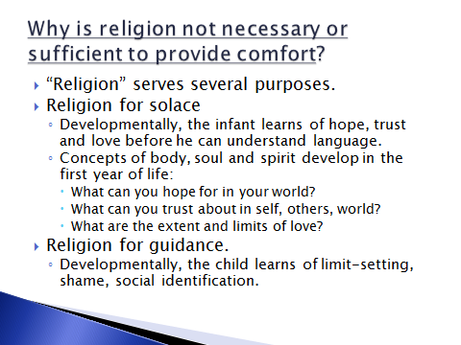
Why is religion neither necessary nor sufficient to provide comfort at the end of life? I came to an answer, one which answers adequately for me at least this apparent paradox in my experience in the hospital.

As I mentioned, I had a course in developmental psychology. The theories are many, but generally reinforcing of each other: different stages of life produce different challenges and opportunities to develop emotional, intellectual and spiritual resources. “Religion” I see as having two different purposes: it can serve as a source of solace, and it can serve as a source of purpose.

Some of our most basic reactions to the world stem from our earliest, pre-verbal experiences. In so-called Attachment Theory, the need of the infant for a responsive caretaker (usually the mother) is critical. Through that relationship in this phase of development, the baby learns whether hope, trust and love are possible. Religion serves similar functions, and could be compensation for inadequate nurturing figures in infancy, or reinforcement of healthy attachments.

Religions also serve to provide guidelines for behaviors and moral values. These are established later in childhood, when children acquire experiences with limit-setting, shame, and social identification. These developmental tasks are inculcated during phases described by famous psychologists such as Freud, Erikson, Piaget and others: the child learns to live with and internalize parental expectations, and then extra-familial social norms are introduced.

It seemed to me that “religion” does not have only one overarching role in lives. Thus, to the extent that “religion” could provide solace, it might be useful to help relieve suffering. It could provide unquestionable calm, peace, a feeling of being loved, accompanied and supported, even in the face of harsh adversity.

And I do not find it difficult to imagine that there are some for whom “religion” serves primarily to require obedience or to provide rules of behavior. Such concepts of religion may not be sufficient to relieve the suffering of loneliness, and death confronts us with the prospect of permanent loneliness.

Conversely, it is not difficult for me to imagine that there are individuals with sufficiently supportive experiences in life who did not need to subscribe to traditional religious practices. Such persons might find not find any “religion” necessary at the end of life, as they could call on other concepts, experiences or relationships to provide hope and love and trust when facing the loneliness of illness and death. As one mystic (Krishnamurthi) suggested, those persons may not go alone into death, as they would bring with them pieces of those who loved them.

So I think I can see “religion” as a choice, a way to see the world with particular answers to the eternal questions. There are many thoughtful and earnest persons addressing the obvious questions of why there are so many religions in the world. Their conversations and debates can be rich and informative. But it is not the stuff of my interest right now.

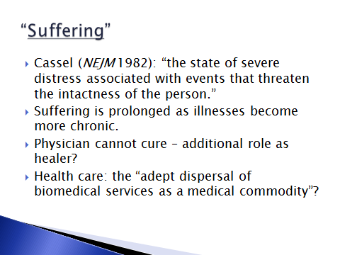

I am also interested in this word that keeps appearing: suffering.

I am not sure there is an easy definition of it. Suffering in medicine was defined by Dr. Eric Cassel in 1982 as “the state of severe distress associated with events that threaten the intactness of the person.” Medical treatments of course attend primarily to physical symptoms, and in hospitals there seems to exist only minimal awareness of this issue of suffering per se, and there is even less support for appreciating and addressing social, psychological, cultural and spiritual sources of suffering. There has been and will be debate if medicine has a responsibility to treat metaphysical and spiritual suffering as equal in importance to physical symptoms, and how to afford such care.

It is clear though that as medical technologies make illnesses more chronic, suffering is prolonged, and the physician is called to be aware of a role as a healer and helper when curing is not possible. The difficulty of the task is multiplied by the evolution of health care into a model of “adept dispersal of biomedical services as a medical commodity.” I believe we need to be aware of the presence of suffering in our patients’ lives, and also in our own. Because the experience of “existential suffering” is related ultimately to how we live our lives and how we find meaning in our lives.

We have studied and trained, and used intellect and experience to be of use to our patients. Students applying to medicine will always say they want to help people. In medicine we learn soon that there are limits to ways of curing, but what happened to that wish to help? For better or for worse, and I saw this in the seminary, lay people expect doctors still to be able to provide “something” when they are chronically ill and terminally ill. They don’t quite realize that we are far more comfortable with the technical aspects than the emotional aspects of our profession. For many of us, we maybe didn’t realize that we would be called to take care of chronic diseases as much as we do. The physiology and pathology of disease were much more interesting.

But we are asked to get patients through it. We will be faced eventually to have to find ways to get ourselves through it. When we let ourselves know it (as in last week’s Cleveland Clinic video), we realize that patients and families come to this place loaded with issues that would be expected to cause suffering. It is the place where they hope they can leave some of it behind – and often they do. I guess my hope is that our awareness of our common humanity with them will allow this place to be a community of support and caring for them when things don’t go well.

But, what will that take??

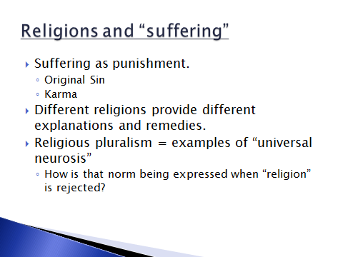

Let me spend a few moments describing a little on what religions have said to why suffering exists.

For many practices there is a streak of judgment: the doctrine of Original Sin in Christianity seems to place the blame on humankind’s pride and self-reliance. I did not study Hinduism, but its offshoot Buddhism recognizes the issue of karma – the part of the soul that is inherited from previous existences, and which is used to explain why there are such inequalities of opportunity that become evident from birth. In the book of Job, Job’s friends asked him to abandon his self-righteousness and examine himself for responsibility for the calamities he experienced.

And of course religions provide reasons and guidelines for how to improve one’s lot. For many people the religious, cultural and social expectations that they grew up with in childhood continue to serve as a norm – they are accepted as a source sometimes of comfort and solace, and perhaps often of guilt, but usually they are not examined for personal meaningfulness. I am speaking to an intellectually gifted audience. But we usually do not examine our religious and spiritual beliefs with the same rigor that we question and examine our academic and technical assumptions.

Here the experience of religious pluralism may hint at an answer. That is, there are so many religions – even if it is a Freudian “universal neurosis” stemming from a need to have a loving mother and father – the fact of its universality must make it a norm. And, if it is a norm, what ways might that norm be expressing itself even, or especially, when formal religion has been rejected?
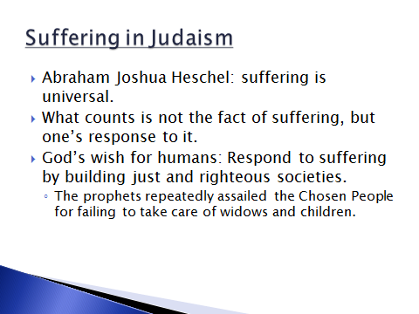

Let me touch very quickly on two religious explanations for the phenomenon of suffering.

Rabbi Heschel has influenced me strongly. Coming deeply from the Jewish tradition, he accepts deeply that suffering is universal. It is not even a question for Jews, he asserts. Job’s “unfair treatment” by God is not the point – individual suffering is not a punishment for anything: it just is and can and will be. What counts is not the fact of suffering: what counts is one’s response to it. And the answer according to Heschel, is to live in justice and righteousness (to care for widows and orphans, and not only to care about riches and power). He says the prophets of the Old Testament portray God as a god of pathos – someone who cares so much for humanity that he keeps reminding and reminding that justice and righteousness are the reasons for their being a Chosen People. When the Assyrians and Babylonians (non-God-fearing cultures) defeated the Jews, it was not because of God’s abandonment, but because the Jews first abandoned the call for justice and righteousness. Justice and righteousness. Since suffering is inherent, the communal response to encourage a better society was the calling of the Jewish God, according to Heschel.
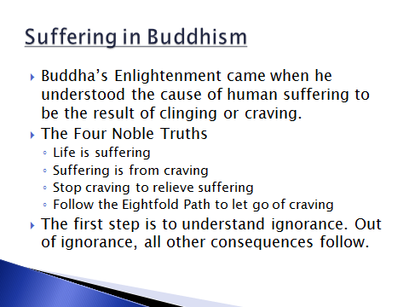

A very different approach to the question of why there is suffering is provided by the Buddha. He lived around 560 or 480 BCE, in a Hindu culture. After years of awareness of and meditation on suffering, trying to answer why death and illness existed, he achieved his Enlightenment, and spent another 30 years spreading his explanations. The Four Noble Truths of the Buddha are: ***. There are many other lists of tenets to remember and study. But underlying all of experience, there is a unity; dualities are not the starting place of reason in Buddhist thought – interconnectedness is. It is not a matter of Either/Or, but Both/And.

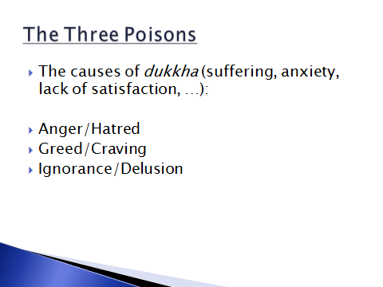

Buddhism identifies Three Poisons that are universal in individuals and in life. The Three Poisons contribute to suffering: there are various definitions and descriptions of the experience of suffering, but they all can be traced to combinations of these Three Poisons.

For Buddhists suffering is an experience that originates within oneself. In this sense, it anticipates psychiatry and neurobiology by thousands of years. Western psychiatry explains emotional balance as malleable, and neuropharmacology clumsily encourages use of medication to alter the sensations of pain, dyspnea, etc., as well as the psychic experiences of anxiety and depression.
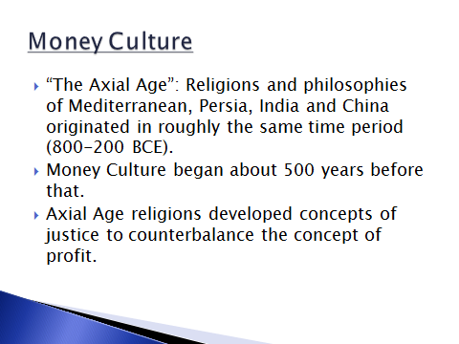

Finally, let me introduce a concept that contributes to maintaining perspective on our daily experiences, and the directions our lives take both personally and collectively. I encountered this theory of the existence of an Axial or pivotal Age. This theory observes that the religions and philosophies of the Mediterranean, Persia, India and China all arose in roughly the same time period, between 800 and 200 BCE. Furthermore, there is theorized that there was a connection between the rise of religions and the rise of money about 500 years before that. The theory posits that the rise of money culture created a tremendous stress on human relationships, stresses that the religions evolved to address. It was then the principles of justice arose. There resulted and has continued to be a struggle between the forces of the market, and the forces of religion.
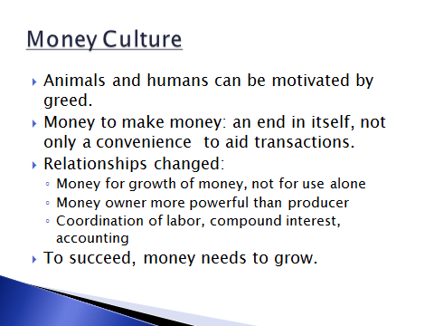

Money Culture appeals to a human urge to greed: in psychology experiments animals and humans can be motivated hugely by money. Money in Money Culture became more than a convenient tool to streamline economic transactions. Acquisition of money became a goal in itself. As a result, human relationships changed: the money owner became more powerful than the producer; relationships became based on money, not interpersonal connection; money was not for use, but for growth. Money allowed property rights beyond one’s personal needs. And in order to succeed, Money Culture needs to expand. Consumerism must be stimulated to support expansion. It is not difficult to see that in today’s world, Money Culture has become a factor and even a norm in cultural and inter-personal activities. It has crossed cultures and its structures are ubiquitous in our lives.
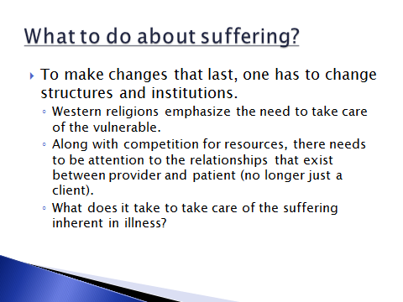

I wanted today to describe how to find ways to resist callousness in medicine.

I will try to address ways we can become more aware of the forces that create callousness in our individual lives, our communal lives, and in American and perhaps global society. The hospital is a huge part of our lives, but to a great degree it is only an example of the society in which it resides. How it deals with the vulnerable and the damaged and dying, reflects how our culture at large approaches these parts of itself.

As I said earlier, as physicians we are about more than tests, procedures, billing and documentation. Our relationships count, to ourselves, our patients and to other members of our communities. We cannot change anything unless we know ourselves and change ourselves. But changing ourselves is not sufficient: to make healthy changes that last, we need to contribute to institutional change also. We need something of the Buddhist emphasis on self-awareness and interconnectedness, and the Western religions’ emphasis on providing justice and righteousness for all members of society, to not ignore the vulnerable (widows and orphans).
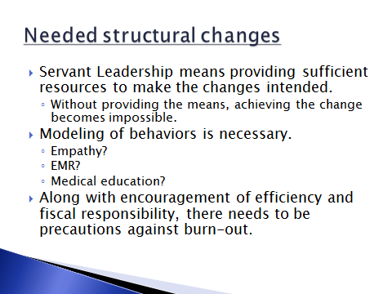

This hospital administration says it supports the concept of Servant Leadership: the idea that leaders are meant to make it possible for others to work. Leaders would start by defining the conditions and a direction, and to conclude by thanking their employees. But in my opinion there has been far too little emphasis on the critical middle function of leadership – to provide resources that make it possible for staff and physicians to make the changes intended. At an institutional level I would offer that there could be better structures to encourage personal development and empathy.

If empathy is to be encouraged, then there should be modeling of empathy for the concerns of employed staff – not merely lip-service to the concept. (It is a said that one should treat employees as you would want them to treat your clients.) If empathy is to be encouraged institutionally, it would include support for self-care and self-examination: therapeutic relationships should not be colored by unexamined emotional issues within the provider. For instance, currently the insurance co-pay for psychological counseling is $80 per session – it makes for a significant disincentive to want to start or continue regular supervision that could be helpful to true empathic growth.

If use of the electronic record is the direction of the future, there should have been and should continue to be much more attention to how to create records that are meaningful to patient care, not just documentation for billing purposes. The record encourages meaningless repetition of clinically non-significant facts, and discourages inclusion of thoughtful and informative data. There are probably means of making the record more meaningful, but there are no resources to teach them, or time to apply them. We have learned that the difficulties with reviewing and typing in the record add hours to every day, and it’s still an inarticulate note filled with inaccuracies that we have put our electronic signatures to. My current solution has been to work with a scribe: it works, but it will cost me over $35,000 a year, though the scribe would only see $25,000. Less experienced scribes are paid even less – and that probably is a guarantee that quality scribes will not stay with the job. Somehow that does not seem to reflect empathy for the workload of physicians.

If the internal medicine program is important for the finances of the hospital, there should be more emphasis on professional development at all levels. The Department of Medicine attracts many talented and motivated young residents every year. They leave with some excellent clinical skills, but they have some bad medical record habits, and they certainly do not always see the best examples of ourselves in medicine. The teaching role of medicine is perhaps the most important one that the leaders in the program and hospital must champion. What do we teach by word, but more importantly by example? What encouragement and training do we offer attendings and faculty? Much like other aspects of our lives that add to meaning, have we abandoned the questioning and the problem-solving in favor of unmindful pursuit of profit? Yes, money helps create opportunities for expressing our desires and wishes, for providing comforts. But at what point does money become more than that?

Along with encouragement of efficiency and fiscal responsibility, there needs to be attention to burn-out and efforts to create conditions to minimize it. The issues are well-described: manageable workload, a sense of control, fair rewards, development of a group identity, fairness in dealing with each other, and clarification of values.

I am sure there could be other examples of institutional support for efforts that provide meaning, support, and increased communal responsibility. I commend the emphasis on a culture of safety. For those who consider it a superficiality, I would remind us that it does serve both purposes: it builds efficiency and it builds relationships. But a culture of safety and a culture of empathy cannot be seen only as means to better scores on Press-Ganey surveys or other instruments of measurement.

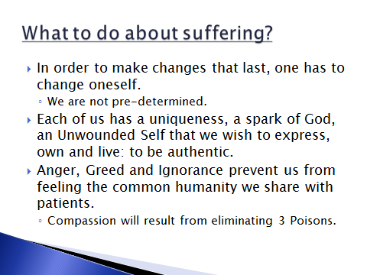

But even while we advocate or criticize, we also have to examine ourselves: physicians, students, administrators, etc. Change starts within ourselves.

We each have a unique destiny for ourselves, one that we can influence and create. Whether we take it from a secular and humanist perspective, a Buddhist perspective of impermanence, or a Judeo-Christian perspective of having choice to live in righteous relationship with God or not – none of us is pre-determined. Without quite knowing where I gather this “knowledge” from, I believe each of us has a spark of God, a spark of divinity within us – it is the valued piece from which we start, the Unwounded Self that we wish to express and own and live: to be authentic.

Buddhism reminds us that Anger, Greed and Ignorance are the Three Poisons in the world. Awareness of these issues is the first step to change. We have touched already on the universality of craving in the world – it involves not only material things, but also craving for things to be as we wish them to be, or as they once were. St. Ignatius warned against riches, status and pride as temptations that drew one toward worldly and away from spiritual purposes.

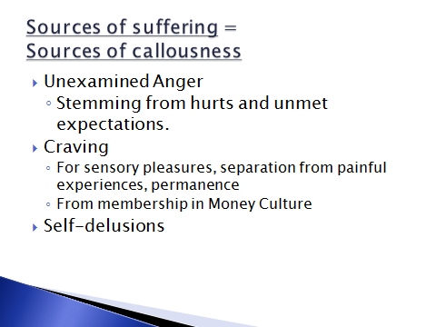

It is remarkable that the sources of suffering are also the sources of callousness.

Psychologists remind us that anger is often connected with unmet expectations or hurts that have not been examined and processed. The Buddhist monks at that conference warned against calls for justice that are rooted in anger. Solutions that do not examine the causes of anger can be hurtful solutions. You have, we have sacrificed much to achieve what we have in our professions and in our institutions. It is necessary to examine and acknowledge the emotional and intellectual traumas that have gone into our “training.” Excellence Everyday can also involve mourning for the opportunities that we have sacrificed in order to further our careers. And we can mourn the losses of personal integrity that have resulted from our acquiescence to the System.

Greed/Craving -

In the Jewish tradition there is a saying that God buried Truth before he made Man. The search for Truth is frustrating, and to question and search for personal answers is exhausting. All of us settle for truths that make us comfortable. The religions have answers to many questions, with the result that there are many answers. The Buddha found the underlying answer in Emptiness – a state of undifferentiated being (Non-being) out of which the lotus and the mud are not essentially different. The Abrahamic religions have a belief in One God who is a creator of all that humans can imagine, and is greater even than that. Another approach says that all religions are like fingers pointing to the moon, but are never capable of representing the moon itself.

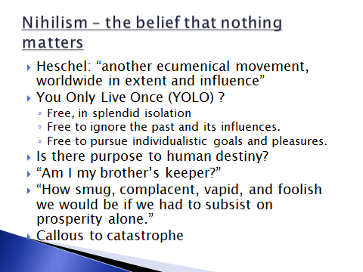

Then there is the belief that nothing matters. This type of spirituality, Nihilism, “is another ecumenical movement, worldwide in extent and influence” (Heschel). To the question of whether there is a purpose to human destiny and how one should live one’s life, there is often (and perhaps easiest) to say that there is no purpose. Scientific rationalism has advanced to a point that it seems that our motivations and our behaviors can almost be explained by our neurobiology. Our appreciation of concepts and forms might be a product of our neural projections and releases of brain dopamine.

The concept (and it is only that) that You Only Live Once allows one the freedom to ignore the past and its influences. It conceives the idea that one can create one’s pleasures and identity anew. It is invigorating in its exploration of interests at the expense of purpose. It allows an existence of “splendid isolation.” And to the question of “Am I my brother’s keeper?” it answers “No.” Heschel fears that this type of callousness is the trend in modern life – that callousness has become a badge of distinction. “How smug, complacent, vapid, and foolish we would be if we had to subsist on prosperity alone.” “Modern man may be characterized as a being who is callous to catastrophe.”

How long can an attitude of YOLO last? What happens to it as one’s physical capacities diminish? When one is visited with injury or illness? When one’s finances are damaged? When one ages? What remains after these pieces of ourselves are taken away? Imagining that future now can perhaps help one address the Present, so that hopefully the suffering that occurs when our own lives become diminished, will be limited.

How to find the truest and best part of ourselves, The Unwounded Self, is the work of a lifetime. We inherit parental expectations and parental habits. We acquire social values and the well-intentioned projections of our teachers, mentors and respected peers. We formulate theories as we develop our conceptual minds. But all of these ideas are subject to change.

As an example: In a conference on Buddhist-Christian dialogue at Union at the end of my stay there, a Buddhist master was asked by a student about the distress she felt in finishing school and the uncertainty of deciding what kind of job she wanted to find and have. The monk asked her if she was suffering in this choosing, and naturally she said yes. The monk kindly but pointedly said that to have this kind of suffering in America would be a sin against the hopes of the rest of the world.

That is a sobering view of what we imagine ourselves to be experiencing.

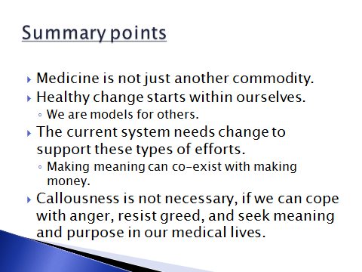

We have come to the time to summarize. First, I have tried to remind us that Medicine is not just another commodity, though the external forces might make it appear so. Medicine is a part of a tradition and a larger purpose richer than its current conception as a service that can be bought and sold. Second, I have tried to emphasize that change starts within ourselves: we only live once, and we each have a role to play, to be models towards others. Thirdly, the current system needs to change to support these types of efforts. Making meaning can co-exist with making money, especially if we become aware of the pervasiveness of a Money Culture that sees keeping, having and getting as virtues more important than being in interconnected relationship with others. Finally, callousness is not necessary – but it requires awareness and willingness to cope with anger, resist greed, and seek to have meaning and purpose in our medical lives.

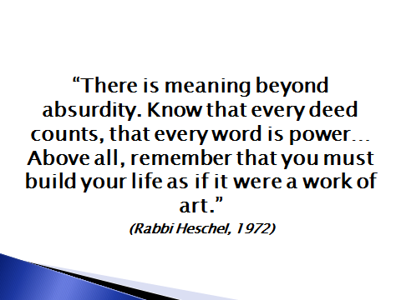
Resisting callousness in medicine is related to living a life that has a purpose that relates to others. It involves acknowledging that we can have an influence, and therefore should make of ourselves an example.

I would encourage each of us to examine, and examine repeatedly, our sources of greed and craving, our sources of anger, and the nature of our self-delusions. There are many resources (prayer, meditation, counseling, pillow-talk, etc.), but they all start with the humility that our lives could be better through examination and sharing of our experiences and ideas.

The word “mindfulness” is popular these days – it is important to remember that what we perceive results from what our minds create. Some, and I would be among them, would encourage a sense of wonder: to realize that our passing through this world is both an accident and a miracle; that we are interconnected so that what we are now is because of what came before, and what we do now will influence that which will come later.

Thank you.

